**Test result report**

**Calculator (calc.exe)**

**13.02.2022-16.02.2022**

**Test team:**

| **Name** | **Position** | **Role in the project** |
| --- | --- | --- |
| Olga Baryliuk | Software Testing Engineer | Tester |

**Testing process description:** Testing of the Calculator application was carried out according to the levels of functional testing: Smoke, Critical Path, Extended. Testing was done manually.

Environment:OS Windows 7, OS Windows 9, OS Windows 10; Browser Chrome; Build 1010

**Summary:** The goal is to test the operation of all the required functions of the application according to the requirements for the app. Successfully completed 95% of smoke test cases and 70% of critical path test cases. 80% of high-priority requirements are implemented correctly, the remaining high-priority and low-priority test cases are scheduled for the next iteration. Critical bugs not found. Quality metrics are in the green zone. The project is expected to be completed on time.

**Testing timetable:**

| Tester | Date | Description | Duration |
| --- | --- | --- | --- |
| Olga Baryliuk | 13.02.2022 | Development of test cases | 6 |
| Olga Baryliuk | 13.02.2022 | Execution of test cases | 2 |
| Olga Baryliuk | 14.02.2022 | Development of test cases | 4 |
| Olga Baryliuk | 14.02.2022 | Execution of test cases | 4 |
| Olga Baryliuk | 15.02.2022 | Execution of test cases | 8 |
| Olga Baryliuk | 16.02.2022 | Writing a bug report | 6 |
| Olga Baryliuk | 16.02.2022 | Writing a Test result report (TRR) | 2 |

**Recommendations**: Pay attention to the lack of the ability to use the application for visually impaired people.

**New bugs found:**

| **ID** | **Bug description** | **Priority** |
| --- | --- | --- |
| 1 | The application is not minimized | Normal |
| 2 | The font size of all signatures is not equal | Normal |

**All bugs statistics:**

| **Status** | **Quantity** | **Severity** | | | |
| --- | --- | --- | --- | --- | --- |
| **Critical** | **Major** | **Medium** | **Minor** |
| New | 2 | 0 | 0 | 2 | 0 |
| In progress | 3 | 0 | 2 | 0 | 1 |
| Fixed | 2 | 0 | 2 | 0 | 0 |
| Verified | 2 | 0 | 2 | 0 | 0 |
| Closed | 2 | 0 | 2 | 0 | 0 |
| Rejected | 0 | 0 | 0 | 0 | 0 |
| Total | 11 | 0 | 8 | 2 | 1 |

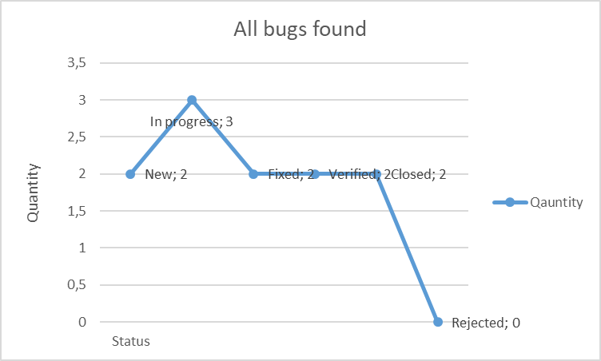

**Metrics:**

Number of completed tests = 100

Number of failed tests = 5

Percentage test cases completed = 100/105 *100 = 95,24%

Percentage test cases failed = 5/105 *100 = 4,76%

Percentage test cases rejected = 0 %